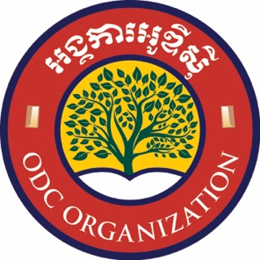
Kingdom of Cambodia
Nation Religion King


ODC ORAIZATION
No: 6293 BrK
Volunteer Application
Opening Doors Cambodia

Volunteer Position Applying for:
____ in-person part-time English program co-instructor

____ remote part-time English program co-instructor

____ in-person speciality short-term program instructor

____ short-term group volunteer program

____ remote youth-to-youth pen pal program participant

Personal Information:
Name ________________________________________________________________________

Sex ___________________________

Age ___________________________

Birthdate ___________________________

Nationality ___________________________

Passport # ___________________________ Date Issued __________________________

Date Expires __________________________

Visa # ___________________________ Date Issued __________________________

Date Expires __________________________

Siem Reap Address _________________________________________________________________

Length of Time in Siem Reap ___________________________________________________________

Reason for Stay _________________________________________________________________
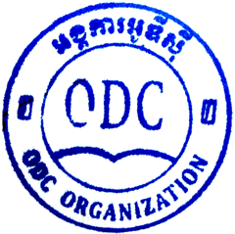
Permanent Address _________________________________________________________________

Contact Information _________________________________________________________________

Your Preferred Contact _________________________________________________________________

English Language Skills:
Are you a native English speaker? ____________________________________________________

If not, when did you learn English? ____________________________________________________

If not, how long did you study English? ____________________________________________________

If not, what is your English proficiency? ____________________________________________________

What skills and talents can you bring to ODC? _____________________________________________

_____________________________________________________________________________________

Educational Information:
Name and address of the institution where you earned your highest educational qualification

Highest qualification earned, including major and year of graduation

Work Experience:
Describe your employment experience relevant to the volunteer position you are applying for

What is your motivation to work as a volunteer at ODC? _______________________________________

_____________________________________________________________________________________

Required Documents:
Along with this application, please attach a copy of the following documents

_____ passport

_____ visa

_____ criminal history background check

_____ two letters of recommendation

Declaration:
I attest that the information I have provided is true to the best of my knowledge.

Signature ________________________________________________________________________
(electronic or signed)
Date ________________________________________________________________________

